Craig Snow
Northrop Grumman
emailaddress@northropgrumman.com

Craig,

Thanks for taking the time to talk at the Career Fair at BYU. I have done more research on Northrop Grumman after talking with you and I was surprised at how aggressively the company has been growing and their plans to continue integrating their divisions. It is impressive to read that they were rated “Company of the Year.” I would be excited about the opportunity to begin my career in such a diverse company. Since you talked to so many people, allow me to give you a brief reminder of who I am.

The most differentiating accomplishment you may remember was spending five days on a cliff face, climbing El Capitan in California’s Yosemite Valley. In conjunction with my ten years of rock climbing, I developed an innovative portable ledge for sleeping on such multi-day ascents. You also seemed impressed that I was very rounded, from other aspects of mountaineering to playing a few musical instruments. Among the other experiences on my resume are being a project manager building a $225,000 Thermo Forming Machine, programming an automated dice drill, and founding the Human Powered Vehicle jr. team at BYU to race a Carbon Composite bicycle. I’ve attached my resume and cover letter, which you should be able to match up with my original resume you took notes on.

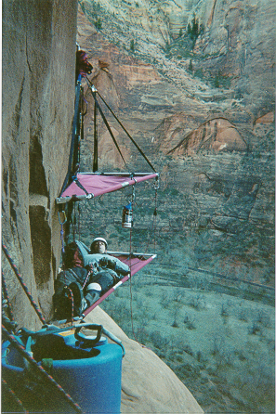
As you gave me your email address, you asked me to send some samples of my work. Specifically, you said I had shown that I have creativity, ambition, and diverse interests, but you wanted to see some examples of my technical aptitude. I hope the samples I have attached are what you had in mind. I asked how much you wanted and you replied to spare no length. I hope this isn’t too exhaustive.

Ledge Analysis (Attached)

This is pretty straightforward. I only included the derivations that show I have a range of structural analysis skills. This analysis is for the dual climber model of the ledge, not the single model (right) shown here and mentioned later. I don’t recall what grade I earned in my structures class, but I do recall how to apply what I learned outside of homework.

HAL Manufacturing Model (Attached)

I must admit that this spreadsheet model is somewhat daunting to initially look at. This format is after my partner and I consolidated everything to only the calculations and tables we used in our final recommendations. It would take a semester to explain the terminology and variables necessary to understand and manipulate the model, but I’ll give you the general idea in a nutshell.

HAL inc. is a manufacturing plant struggling to meet their performance goals. We were given the case study with a list of measured performance indicators for individual machines, and for the plant as a whole. Using that info we built (from scratch) a mathematical model of the plant to indicate where key problem areas were, and predict what results particular changes would produce. We were given three goals to meet. (1) Successfully model the plant in its current condition such that the given micro inputs resulted in the observed outputs of the plant. (2) Using the model, find a reasonable way to allocate the resources to meet the designed capability of the plant; Throughput (TH) = 2000 /day. (3) Develop a reasonable way to meet the managers production goals of TH = 3000 /day.

While this model is not very aesthetic for presentation, it is very conveniently organized for manipulation. To give you a quick glance at what controls and constraints were available, I have highlighted the inputs we had control over in light blue, and some of the key indicators in light green. Most of the given variables are in gray, and many intermediate calculations are plain.

I am aware that I won’t be modeling manufacturing processes, so I include this as an example of my ability to develop a complex mathematical representation of a system involving many interrelated variables, and to use that model to reach particular design goals.

Ledge Invention Process (Attached)

This brief article on the ledge I developed is something I put together recently for an invention competition, and is currently in the finalist running. It doesn’t show any quantitative skills, but it does illustrate the design process I went through and the soft skills of written communication.

Project Manager: Dual Shuttle Thermo Forming Machine

You asked about a little more information on this project, and although I do not have any pictures, I can tell you more about the experience.

This machine is a plastics vacuum forming machine with two forming stations on opposite sides of a shared heating station. It has a forming capacity of 4’ x 5’ sheets, and the entire machine is 18’ long, 10’ wide, and 9’ tall. The machine had been modeled in CAD (IDEAS) when I arrived. I was responsible to bring the machine from computer screen to reality in 8 months. Please feel free to contact the President of Quality Plastics, Guy Gardner, and talk with him about the scope of the project (775) 555–5555.

After thinking through the demands of this project, it seems that most of the skills I developed will become valuable to Northrop Grumman after I have been with the company over a year. The first thing I did upon arrival was to study and become familiar with the machine, its intended uses, and what had driven the design decisions. Next I laid out a schedule covering all the tasks that needed to be performed to complete the machine, starting generally and branching down to the detailed components (based on a GANT Chart format). Before beginning to order materials I composed a budget including all the known and estimated expenses. Finally I began ordering materials and executing the fabrication and construction.

The exposure and experience I gained in manufacturing and fabricating this machine is invaluable to making educated design decisions. Although I do not intend to build a career in manufacturing or engineering technology, I am very glad to have had the opportunity to see first hand how different materials react to different manufacturing processes. Gaining exposure to the various tooling materials and coatings that enhance particular properties opened my eyes to a whole range of possibilities to manipulate component performance. In the aerospace industry where every component is very function specific, such materials application opens a controlling dimension beyond structural design. To make some specific components, I took advantage of the expansion ratio between steel and aluminum in building the tooling. I used metals of different hardness, damping, and bearing properties (bronze, brass, “gray” iron, UHMW polyethylene, etc.) for function specific components.

I thoroughly enjoyed managing this project and driving the progress every day on the machine, but the one element that I would like to be more involved in is the quantitative aspect of engineering. One of the things I enjoyed about designing my ledge was that weight was very important, and performing the analysis proved to be useful. At Northrop Grumman I hope to work on projects where it is important to optimize the design. Every ounce that goes up on a satellite is very expensive, but a failure in space is irreparable. The combination of my general analytical and working skills with my desire to continue developing the technical skills from my degree position me to contribute to Northrop engineering teams right from the start.

Automated Dice Drill

The experience I have gained in automation programming is uniquely valuable to the aerospace industry. My resume mentions only one Automated Dice Drill, but during two months while I was building the thermo forming machine, I also had the opportunity to program a second dice drill that had been developed with some significant improvements. This second machine employed a return mechanism that sent the cubes through the same drills for the second drilling cycle, eliminating the necessity of two drilling stations.

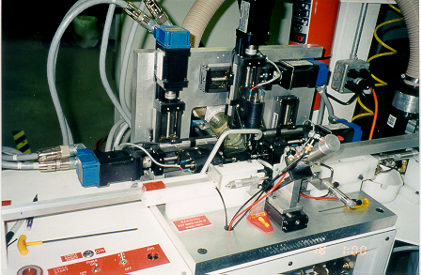

In the view shown, the cubes were fed in through a cartridge (starting at right), clamped into an anvil by a pneumatic cylinder, carried into the drill station where three servo controlled drills were coordinated to simultaneously drill the necessary holes. Then the cube was ejected through a transfer chute (left) and properly oriented for the second station (not shown) to drill the remaining three sides.

The real challenge was in optimizing the process, and at the same time making it idiot proof. The program was run through a PC interface communicating with the servo drivers and I/O units controlling the pneumatics. There were many commands that had initially been programmed to unnecessarily wait for previous operations to finish. There were many more commands that could be triggered inadvertently, resulting in crashing the machine. The challenge was in finding which operations it was necessary to wait for, how long to wait for them, how to flag commands prior to their natural sequence, and to insert the necessary algorithms that would prevent these processes from beginning impulsively while allowing them to begin when desired. In total, I brought the cycle time from 12 seconds down to 5 seconds, and worked out (apparently) every program bug. Such system integration is not directly applicable to stress analysis or heat transfer, but it is highly important when designing for the overall systems operating within a satellite, or an individual mechanism within the satellite. This ability to understand and coordinate the interaction of many different variables may not be used during my first year with Northrop, but it will doubtless be valuable as I progress within the company.

It is significant to note that when I was hired as an intern, it was never the company’s intention to give me responsibility over this machine. Among my other responsibilities, I was helping their full time engineer develop the program and build the smaller mechanisms to finish the mechanical functions of the machine. More often than not, I was the one left to dig through and analyze the maze of algorithms and commands in the program, to understand the problems we were running into. Over time, I became the expert on the machine, and they gave me full responsibility for it.

When we finally delivered the machine (on time) to the company we had contracted to build it for, everything went perfectly. The President of Quality Plastics planned on me delivering the machine and spending the day before he came setting it up. He arrived expecting to stay for three days trouble shooting the inevitable problems that would appear. He saw I had everything under control and gladly flew out the next morning, confident that I could handle anything that came up, and leaving me to train the new owners and operators.

Human Powered Vehicle

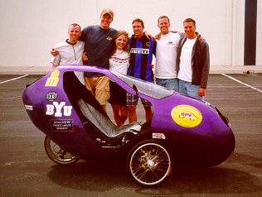
Exposure to composites. The best part of this experience is that everybody who was on the team was there simply because they wanted to have a good time applying and enhancing their engineering skills. We gained exposure to composites in both pre-preg and wet lay-up, and the functional performance of the materials (The body and frame had been designed by a pervious year senior design team). I saw how composite materials can be fabricated to produce very specific and directional performance. They’re not a cure-all design material, but can be very useful in the proper applications.
The HPV team after placing 1st in the utility race at the ASME national competition. I’m in the blue and black striped shirt.

In conclusion to this letter I’ll run through a few of the less job related reasons I want to work with Northrop Grumman. I would like to live and work in California. I lived there for four years while growing up, and I still like the atmosphere whenever I travel back. It carries an attitude of ambition and success with a touch of sun. I plan on continuing my education and there are a number of reputable schools throughout the entire state. Although Northrop has become the second largest defense contractor, it is still the product of a number of somewhat recent acquisitions. It appears that this offers the stability and strength of a giant combined with the personality of closer niche expertise in the individual branches.

I appreciate your time and I hope this has been what you had in mind. I hope this has shown I am sincerely interested in further investigating opportunities with Northrop Grumman. If there is anything else you would like me to send, I will be happy to comply. I will contact you again in a week if I don’t hear back. Thanks again for your time and consideration.

Sincerely,

Bryan Gardner
bryan.gardner@byu.edu
(801) 372-3452

